Conclusions and Future work

Discussions

Discussions on the System Bus.

Data bus
The standard used in Ryerson constructed CubeSats is already quite similar to those used by others in their CubeSats. This similarity is a positive indication that a standard based on this work could be widely accepted as a common standard. Furthermore this standard is also relatively low in cost and requires no special connectors or specialized hardware. Although the author has not been able to prove full reliability at a system wide level, as most subsystems are still in development. Early breadboard tests have shown little to no problems with the interface, illustrating an early level of repeatability and reliability. The subsystems developed thus far are fully compatible with earlier bread board models proving that the standard can allow for incremental improvements and development of a system. In addition, only the slowest speed data rate has been used, implying there is room for improvement in the data rate. What is currently lacking (to the knowledge of the author) is a bridge from I2C to other space compatible interfaces like SpaceWire.
Although no standard can ever solve all problems, the standard proposed by the author does handle low data transmission requirements well, and is scalable for future missions. Additionally, this bus setup is similar to the already proven MIL-STD-1553 bus, and is scalable both upwards and downwards to allow for both space-qualifying of future equipment on CubeSats, or for future subsystems-on-a-chip designs. In any case the work presented may be the beginnings of an industry accepted standard and may be is a positive step towards formalizing a standard that is already being organically developed by pico-satellite developers thus far.

Discussions on System Design and Work Breakdown
For future missions, it should be recommended that more early research and testing be completed on system interfaces and a reference design should be supplied to the subsystem developers. Doing this will allow other subsystem designers to work with the actual protocols in hand, and will reduce time wasted by each subsystem designer reproducing the code required to utilize these protocols. The reference design also will allow future developers to test their own device in a more realistic manner. The team size should be increased for each subsystem with one individual focused on developing the hardware and another focused on simulation and developing code suitable for the hardware, in most cases a single person handling both critical jobs was not enough.

Discussions on Power Subsystem
The power subsystem as presented is a working breadboard level of the actual spacecraft part; there was however some minor errors and improvements that should be corrected and added before further testing and eventually space flight. However these modifications are minor and should not affect the system code.

Modification to Reduce Parts for AND Gate Controlling Secondary Supply Systems
This modification would remove the LTC1440, SN74AHC540, SN74LVC1G14 and the supporting resistors, in exchange for a simpler & smaller Brownout supervisory IC such as the MPC130. This design change could free up about 1 square inch of board space and will simplify the design assembly and testing of this part of the power subsystem.
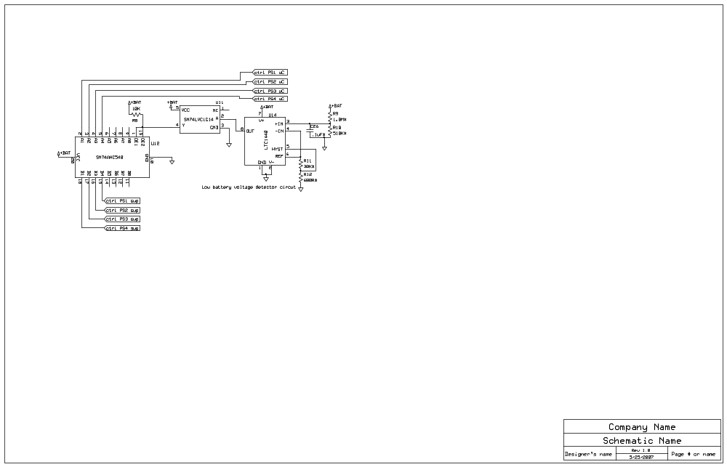 | 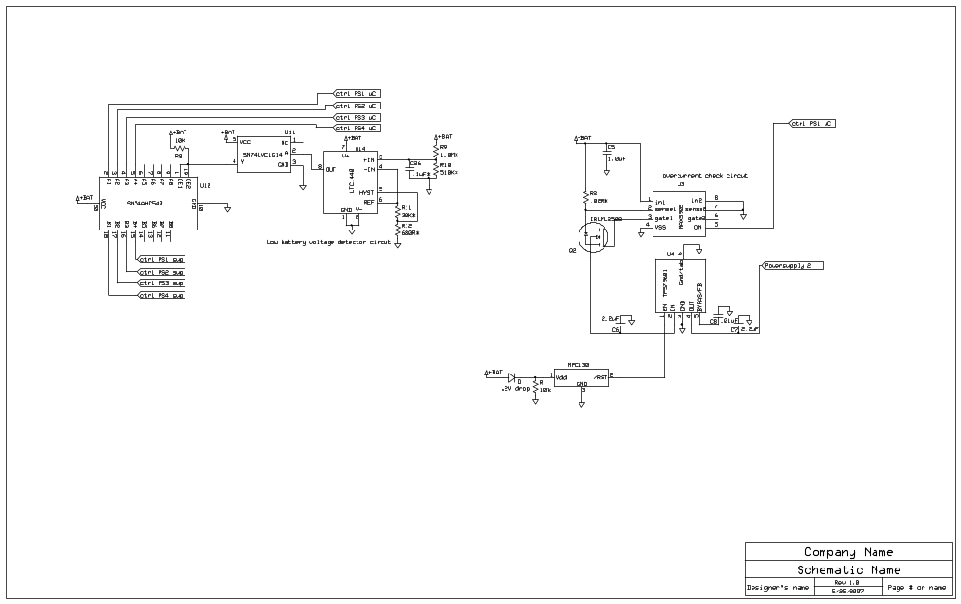
Figure 1: Current setup to be removed | Figure 2: Example of replacement

Addition of Pull-down Resistors to Secondary Supply Line Controls Lines
In this prototype pull down resistors were added to the lines that control the turning on of the secondary supply lines to ensure the subsystems would remain off in a reset condition. This fix was found to be not enough, as when the system was held in reset, the floating voltage from the controlling pins on the microcontroller was sufficient to trigger the SN74AH540 to turn on the lines. To further correct this current setup more pull down resistors will be needed on each of the lines supplied from the microcontroller. Again if the above replacement circuit is used this will not be an issue.

Modification of the Uninterruptable Power Supply to Make Programming Easier With MikroC ICD
This modification is really just for development, it involves separating the uninterruptible 3.3V from the power subsystems 3.3V logic supply to allow programming with the 5V programmer available in the lab. As the pins are doubled up on the interface and elsewhere on the satellite, the 3.3V uninterruptible line would be connected on the other subsystems. This change would allow the logic voltage be supplied independently by the programmer/debugger interface. It should be noted that this modification will not be needed on any other board as they all have independent voltage sources from the power subsystem.
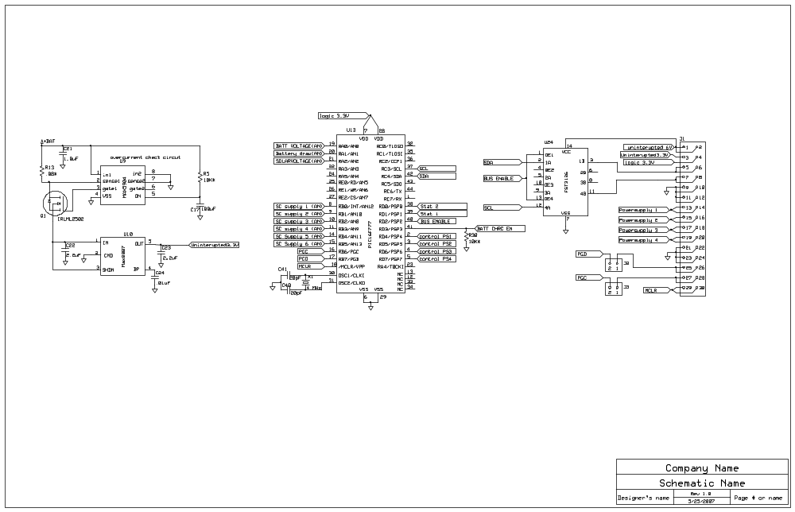
Figure 3: Modification to simplify programming

Pull-up Resistors for Battery Charger Status
This modification is a correction of a design oversight it simply requires the addition of two pull up resistors placed on the status lines of the battery charge circuit to allow the status to be read by the microcontroller

Modification to Directly Monitor Status of Power Supplies
Again yet another design oversight, although the system has a way of turning off a secondary system if it draws too much current, the microcontroller has no direct way of detecting this case, this can be easily rectified by connecting 4 unused pins from the microcontroller to the outputs of the source, the microcontroller’s code would then in addition to reading the status of the control port read the status of these pins when answering queries about the status of the power supplies.

Harmonization of LDO Voltage Regulators
This modification is more to simplify assembly and testing. By replacing the MAX8887 LDO’s with the TPS79633 LDO’s, each supply line would then utilize the same part, allowing for greater flexibility for modification of these power boards for future missions at a cost of 600μA. This change will also ensure these devices are not operating close to their published output current limits.

Investigate Different Battery Charge Management IC’s
During testing, it was found that this particular IC was fairly inefficient, as it operated as a linear dropout regulator, dissipating the .8V difference between the boost convert and itself as heat. A different battery charger IC that acts as a switch between the battery and supply voltage (such as the bq24070) would be more efficient and would allow more power to transfer from the solar cells to the battery. The other option would be to utilize the microcontroller as the battery charging supervisor.

Change of 5V Boost Converter to Handle More Current and be Less Prone to Failure
During testing these devices proved to be problematic, failing several times. Although in all cases the cause of the failure was user or assembly error. To improve the reliability of these subsystems a study should be completed to determine which of the similar devices available on the market are the most reliable, easy to solder and most robust against user error.

Addition of Adjustable +Vref
During testing of the code it became apparent that an adjustable Vref would have been quite handy in increasing the measurement accuracy of the current readings. The simple addition of an adjustable (but lockable) resistor bridge to the +Vref pin (AN4) would have allowed greater measurement accuracy of the current measurements. As the PIC devices allow for a choice of reference voltage sources in software this would not have an effect on other measured values on the board.

Change Board Layout to act as a Bridge from Ryerson Architecture to Pumpkin’s CubeSat Kit
This board would be a logical place to add a bridge between our previous Ryerson devised pin out and that of the CubeSat kits. The major difference between the two standards is the physical interface and the way power to subsystems is individually controlled by the power subsystem. The modification would divert the 3.3V& 5V uninterruptible lines to the base CubeSat kit flight module, carry the I2C lines from the Flight module to our standard interface and safely terminate all of the extra pins on the CubeSat kit. The form factor of the board would also have to be changed to allow for mounting within the standard pumpkin CubeSat kit’s structure and allow room the vertically mounted magnetic torque coil and reaction wheels from the ACS subsystem.

Overall
The power subsystem created here is most likely only one or two revisions away from being ready for spaceflight on an RyeSat. If the work proposed in the discussion and the testing suggested in the future work section is completed, there should be no reason for this device not to become an integral part of RyeSat and future missions from the Space Systems and Dynamics & Controls group at Ryerson.

Discussion on ACS & ADS Subsystems
In hindsight the interactions between the ADS and ACS were poorly defined in the initial design. Although the idea of separating these systems is still a valid idea, there is a major lack of understanding as to how they will function. In the initial proposal the idea was to utilize the ADS to filter, calibrate, and gather data, from analog sensors. The C&DH subsystem (or main master) would then apply the control law and send commands to the relatively dumb ACS who would then turn on the torque coils.
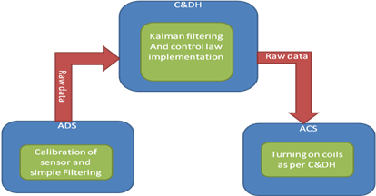 | 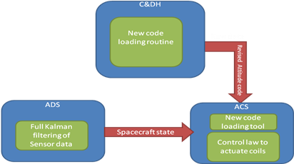
Figure 4: Current configuration of ADCS system | Figure 5: Proposed change to operation of attitude determination and attitude control subsystems

One problem with this approach is that it involved the active participation of the C&DH module (which could be busy doing other things such as decoding radio signals or dealing with payload data). The other problem with this setup is the magnetometer is currently located on the ADS subsystem preventing the ACS from directly knowing what magnetic field it is torquing against, this hinders the capability of the ACS greatly.
A better strategy would be to add a remote I2C based Magnetometer available to both the ADS and ACS, this would allow for placement of the magnetometer further away from the torquing coils and the radio, it would also allow the ACS to act more intelligently in its application of the magnetic torque coils. The other option is to duplicate the magnetometer on both modules allowing each to have direct access to the measured magnetic field, although this alternative will be affected more by the other magnetic fields in the spacecraft.
the other change that should be made to the overall design is the division of work for each component of the ADCS, first a full Kalman filter should be run on the ADS module, this device could then just be polled for the spacecrafts current attitude states by either the C&DH for transmission to earth or by the ACS for determining the control outputs. The second main change is to the ACS, this subsystem should be a field reprogrammable device allowing the ground team to easily load and test new control algorithms while in orbit.

Discussions on CubeSats in General
Pico-satellites are viable development platforms for testing new technologies in the space environment. The opportunities given to fly the earliest pico-satellites as secondary payloads have benefited all facets of the space community, both by effectively training the next generation of spacecraft designers and by pushing the boundaries of space technology at largely reduced risk and cost. The CubeSat standard is a wonderful way for universities and companies to participate in small satellite design. With a larger number of universities and companies doing research in small satellites, one can expect complex space technologies to be developed even faster. Already the development of space technology through CubeSats is evident with missions like CanX-2. It is felt by the author that future CubeSat missions will become even more complex, and will eventually be performing the tasks traditionally expected by nano and micro-satellites, such as operating inexpensive telescopes. And even if physical requirements prevent CubeSats from performing these tasks (such as inability to scale down optics), the technology developed for CubeSats will influence larger systems by creating technology that has lower mass and power requirements. Also with all the work being done on CubeSats it is just a matter of time before the next smaller sized satellites (femto-satellites) are flown in orbit. Again, similar to the development of pico-satellites, these femto-satellites will at first be simple radio projects (maybe in time there will be a future paper touting the advantages of femto-satellites as viable replacements for pico-satellites.) Regardless of the fact if pico or femto-satellites replace larger satellites, all of this research surrounding these miniature satellites will benefit the development of innovative and reliable space technologies with an emphasis on miniaturization.

Future work

System Bus
An effort should be made to create a module that will allow our developed systems to interact with the industry standard CubeSat kit. Creation of this bridge will allow our team to bypass further development of the C&DH hardware and spend the time further developing the ACS ADS and payload modules. Also a re-examination of the board standard should be undertaken to allow it to fit together with the CubeSat kit pc104 standard. This change may prove to speed up development and allow our devices to be utilized by more CubeSat teams around the globe.

Power Subsystem
As stated earlier the power subsystem testing is still incomplete, however the apparatus required was unavailable during the development of this breadboard model and is relatively costly.

Environmental Testing
To ensure the power subsystem will perform in the space environment there are several tests that need to be completed including a Vacuum test of the selected lithium ion cells, a full vacuum test of the charging system and battery, and a test with the estimated extreme temperatures.

Testing with Actual Solar Cells
Although some limited testing has begun with some locally available solar cells no testing of the subsystem has been done with the anticipated 26% efficient cells from Spectrolabs. Field testing of this system with the specified cells would further increase the reliability and confidence with this system and will allow the opportunity to discover any potential problems with the design using these high efficiency cells.

ADS
The ADS subsystem will require more study. Initially the sensors utilized (magnetometer, solar cell inputs, rate gyros) should be modeled with high fidelity with a simulated environment there are some commercially available models such as STK that could be capable of this task. Next effort should be focused on creating a simplified sensor fusion algorithm for these sensors in the simulated environment (such as a standard or extended Kalman filter). Efforts should then be focused on developing and testing the hardware and firmware for this system. Finally this firmware should be tested with hardware in the loop simulation to verify is correctness.

ACS
The ACS Subsystem is another system that will require the full attention of a single design team. The design challenges here are focused on developing a system to reliably and remotely reprogram the control algorithms in the space environment. As the actual control of the coils or reaction wheels is a relatively simple task with the use of the standard PIC PWM interface and the selected H-Bridge modules. The other task left in this system is the development and testing of attitude control algorithms suitable for use with magnetic torque coils using the data that is available from the ADS module.

